Implementing a Web Application, which provide High School students, who are physical not able to attend classes, with a live access to the class lecture and create a method for tracking their participation

570027- Semida Andreicha

567501- Natalia Golova

564403- Natalia Karpova

Inholland University of Applied Science

**Abstract**

This paper explores the development of a Web Application that results from the prerequisite education, from Elementary to High School, and mandatory attendance to class lectures. The research is aimed to develop an Application that will allow all students to have remote access to learning, despite of the situations. The development of the Web Application varies between the back end codding (creation of the database) and the front end work (the web design and front end web development). This paper provides a possible solution to students, who have to attend Schools, and closely examines the development of the Web Application prototype.

**Keywords:** *database, design and web development, Web Application prototype*

# 1 – Introduction

In this paper presents the development of a prototype of a Web Application, which can provide students in Schools with a chance to have access to education even though they are physically unable to be there. Schools have most of the students following regular classes and taking regular exams, however for some students this is impossible due to illness or impracticalities, such as being involved in performances as a high-level athlete. Consequently, those students miss classes and important lectures, thus the need of development of a prototype which can provide all students the opportunity to attend lectures is crucial. The prototype of the Web Application is intended to provide a satisfying VoIP[1], which stands for Voice over Internet Protocol, and allows teachers to communicate with their students over the Internet using their voice. Design with hyperlinks to the database, virtual live access to lectures, timeline, as well as the upload and download of files, the scholastic Web Application will clearly stand out in comparison to other applications such as Skype, Viber, or OoVoO. This paper provides an in-depth description of the focus of creating, developing and implementing a Web Application with which students can virtually attend and conveniently take classes over the internet.

# 2 – Context and Research Question

## 2.1 Context

High Schools such as Helen Parkhurst {1-01}, located in Almere and which has about 1700 students whom follow classes at three different levels of education VMBO-T[2], HAVO[3], and VWO[4], often face situations where students are unable to attend classes. Although most of the students are following regular classes and take regular exams, some students find this impossible, due to either illnesses or impracticalities, due to their implication in performances such as sports on a (semi) professional level or competitions. Therefore, because of those circumstances, students miss classes and important lessons. Nevertheless, classes are mandatory by law, thus any unattested reasons, given by the student to be absent, must be verified. Hence, teachers have to keep records of all absentees, and all the students who have physical incapability of attending classes gives rise to a lot of bookkeeping as well potential penalties might be applied, such as expulsion for a period of time. Concerning this is not the only issue with the students who are unable to attend classes, important materials such as handouts given during classes and essential instructions of completion for their courses will be also missed by them. To help solve this critical problem a cooperation between VoiceWorks[5] {2-02}  and Inholland University of Applied Science {3-03} first year students was established. The majority of the work was solely done by students under the supervision of VoiceWorks member Milos Radujkov and university teacher advisors Harald Drillenburg and Belinda Kroes.

## 2.2 Main Research Question

The main research question describes the fundamental focus of the research in a short sentence.

How to provide High School students, who are physically not able to attend classes, with an opportunity to the class lecture and implement a method for tracking their participation?

## 2.3 Sub-Questions

The main question is then further divided into sub-questions to ensure a steady step by step development of the application and providing answers that will eventually answer the main research question.

1. Which type of access will suite the purpose and how to implement it?

2. How to track student’s attendance during such classes?

3. What data about students should be stored and how?

4. How to implement an interface, attendance tracker and connection to the data storage for such an access?

# 3 – Research Strategy

The research strategy that will be carried out through the development of the Web Application involves a number of very important phases of development.

In the first phase, the type of research is being established, in this study both qualitative research and quantitative research have been used to gather important data. Initially we design an interview [1-1] and survey [1-2] from which more information will be gathered from both the teachers and students. Qualitative research is aimed to gather an in-depth understanding of the needs that are compulsory to be meet by Web Application. Along with the interview a survey will also be conducted, by both the teachers and the students, to make sure that no important information is lost.

The second phase, of the research strategy is defining the units of analysis and the constructs. The unit of analysis used in this research is type of the remote access which allow students to be present during the lectures. The constructs of analysis are the functionalities that the Web Application holds. Such functionalities include the possibility to track attendance, provide each student with a personal account and to keep as well as display data, which is gathered during the online lectures.

Taking part in the third phase is the analyzation of the data, which was obtained through the interviews and the survey. Closely examining the most important features, that must be present in the end product, and the complexities which the development process will be up with. Then develop a plan of the steps that need to be fulfilled, to meet the client’s demands and needs*.*

Lastly the forth phase, which is the development and testing of the prototype. In order to guarantee a well-developed product to the clients, a test must firstly be conducted and then very comprehensively evaluate the outcome. With meticulous comparisons between the demands of the client and the product outcome, the research aspires to satisfy and accomplish all the requirements.

The communication, done by the developers during the development of the Web Application, will be mainly done through the social media website Facebook. However, all documentations and all the files that each member has completed will be uploaded on GitHub and Git, control system were information will be collectively edited and saved to current versions of the files or documents.

# 4 – Methods

The student’s part in research consist of building a user-friendly interface and data access to the sample database, as well as provide the possibility to both alter and add new information to the existing database upon enhancing the provided Web Application. Protection, security features as well as minimum time-consuming way to work with data were also taken under consideration for the development of the Web Application.

In principle, the design of the implementation of the Web Application is divided into two main and different parts: One is to implement a database that will suit the purpose of the project, the back end work which is described in detail in section 4.1. The other is to implement an interface that establishes an easy way to be handled by both the students and the teachers, the front end work elaborated in section 4.2.  
 The development began with an initial extensive lay out of an online application, which has been provided for this research by VoiceWorks. This application had already implemented a series of very important demands that the final product must have included such as a live video and audio connection as well as an e-mail service. In addition VoiceWorks provided access to their libraries, UCConnect[6]{4-04}, along with the usage of other files, such as JavaScript{5-05}.

## 4.1 – Back End Work Development

The work process of the development of the Web Application consist of three distinct parts: creation, implementation, connection and optimization of the database. These parts fall under the category of a back-end work. Here the initial steps were to create the models, conceptual data model [1-3] [7] and logical data view [1-4] [8], which will reflect the client’s requests.

The approach that was selected for the implementation of the database relies solely on the observations which were drawn from the client’s description of needs. Due to the student’s busy schedule the interviews and the surveys, predesigned to help have a better understanding of what the core idea and essentialities are being expected in the final product, had to be undertaken by other clients. However this has had little influence for the development of the application due to the fact that the substitute clients had a precise understanding of what the students struggle with and have needs of.

Firstly, the conceptual data model [1-3] of the database was created using the gathered information. The conceptual data model, was drafted after the detailed analysis of the most important needs that must be included in the database. Then once reached a final conceptual data model, the process of translating the conceptual data model into the logical view has proceeded. Once the logical model has been completed the process of normalization[9] began. In the process of normalization the implementation of the most important aspects that the databases were sustained as must have in order for the database to be well-functional.

MySQL {6-06}, which is a relational database management system, was chosen as the main language to build up a database, develop queries and help maintain the database. For the reason that a real data was not provided during the research, a database was created. The database was developed and filled with a sample data, by writing scripts which reflected the logical model.

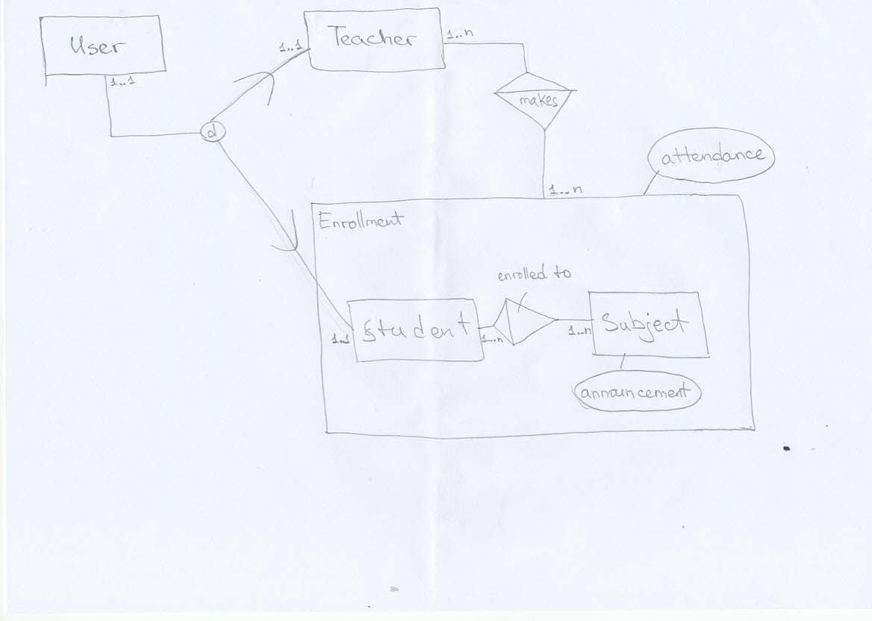

Conceptual Data Model [1-3]

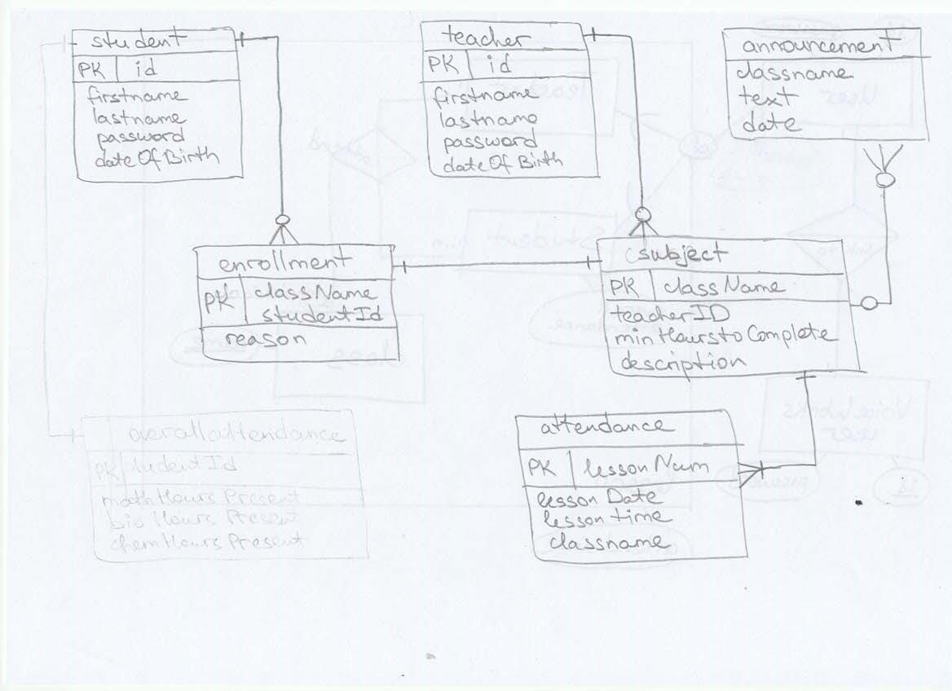

Logical View [1-4]

The steps that were taken to develop the data access, which is the connection between the online application and the database, were divided in two parts. The first part was established by using PHP {7-07}, server-side scripting language, to create a connection to the database. The second part was to create a set of SQL statements to access data from the database.

After the establishment of developing the data access the development of the back-end work has continued. Likewise mentioned a part of the necessary implementations was already provided by VoiceWorks. It includes various JavaScript functions which use VoiceWorks libraries to connect to the VoiceWorks services and provide a user with VoIP services. The other part of the back-end work was solely done by the students. This part included the displaying of the necessary data from the database, its maintenance and automatic updating with request of the user. Also the insertion of SQL statements to the cod and compel a working environment with the other part of the code; optimization of loops and securing updating functions.

## 4.2 – Front End Work Development

Meanwhile the front end work, of the web design, has been actively completed form a times spam from May 2016 till the middle of the June 2016. Making significant progress in designing an interface and implementing it with different coding languages.

[The web design was implemented only after the work on back-end and data access was finished, and it includes various techniques as iFrames, CSS and jQuery (I do not for now, let`s wait Natalia to finish front end). ]

# 5 – Results

One of the aims of the research paper was to provide students with a chance to education. This operability of having access to having remotely live access to lectures via Internet, with the students being away from their Schools in foreign countries or even hospitals, and their subject class, in Helen Parkhurst School located in Almere. The research paper has therefore been used to provide and develop a Web Application prototype which will help students overcome their impracticalities.

Before proceeding with the research, one of the main concerns was related to what exactly the students’ needs were, however with the complications in gathering the necessary data to begin the development of the Web Application the process was lengthy. However, after conducting several research methods, involving both qualitative research and quantitative research, the purpose of the research came into view. Once finished with gathering all the information, the data was then separated into two main focuses the front end work and the back end work. For this reason, .

Further upgrades are required for a long-term stabile, tech-friendly and modernized Web Application that the students will enjoy working with.

# 6 – Conclusions

Due to illnesses or extracurricular activities a lot of students miss classes, thus numerous absences lead to a lot of problems. A solution which can solve this problem is the development of a Web Application. The Web application can provide students with a remote way of being able to keep up with their education while they are away.

The main research question for this paper was “How to provide High School students, who are physically not able to attend classes, with an opportunity to the class lecture and implement a method for tracking their participation?” and can be found in section 2.2.

The first sub-research question, found in section 2.1, has as an answer __ as shown in section___.

The second sub-research question, found in section 2.1, has as an answer __ as shown in section___.

The third sub-research question, found in section 2.1, has as an answer __ as shown in section___.

The fourth and last sub-research question, found in section 2.1, has as an answer __ as shown in section___.

As for the main research question the result can be found in detail in section 5 of the research paper.

The research concluded that special resources and specialists/technicians are needed to develop the VoIP.

# 7 – Recommendations

The following recommendations are offered as possible ways to be implemented as an up-grade in the next development of the product.

1. Have implemented a chat conversation, this is where students can ask questions or share opinions on different topics and have feedback from their fellow colleagues and teachers.

2. Record the live lectures, and have them available to students who are incapable to attend class at the same time as the live lecture is occurring, due to time difference or other circumstances. Thus if the recording will be available to students at any given time, they will feel less pressure of always trying to be at the same time online as the live lecture.

3. Implement a reward system, such as for every minute the student watched a video lecture they will be awarded points. These points could then be related to the attendance, making the system of learning more disposable and not needing a physical presence.

4. In the next up-grade, another very important feature that will help enhance student’s educational skills will be a topic related pop-up questions. The pop-up will appear during the playing of the recorded video, and will have questions that the teachers predesigned. Once the student enters or chooses the right answer the video will keep on playing, however if the student will choose a wrong answer the video will be rewound to a specific point in the video.

5. One of the last implementation recommendations is adding a calendar to the main page of the Web Application. The calendar will hold all important information such as the upcoming due date of each assignment, as well as the upload date of assignments. This will help students keep track of all of their class time and lectures while they are away.

# 8 - Sources

1. {1-01} *Helen Parkhurst*. N.p., Apr. 2016. Web. June 2016 <http://helenpark.nl/>
2. {2-02} *VoiceWorks*. N.p., Apr. 2016. Web. June 2016 <http://www.voiceworks.com/nl>
3. {3-03} *Inholland University of Applied Science*. N.p., Apr. 2016. Web. June 2016 <https://inholland.nl/>
4. {4-04} *UCConnect*. N.p., Apr. 2016. Web. June 2016 <https://developer.ucconnect.io/docs/UCConnect.html#.fetchMemberList>
5. {5-05} *JavaScript.* N.p., Apr. 2016. Web. June 2016 <https://www.javascript.com/>
6. {6-06} *MySQL*. N.p., Apr. 2016. Web. June 2016 <http://www.mysql.com/>
7. {7-07} *PHP*. N.p., Apr. 2016. Web. June 2016 <http://php.net/>
8. "A Practical Guide to technical reports and presentations for Scientists, Engineers, and Students" Pauline Bary-Khan, Elizabeth Hildinger, Erik Hildinger; Person Learning Solution 2010
9. "Web Programming Step by Step" (2nd edition) Marty Stepp, Jessica Miller, Victoria Krist; independently self-published via Lulu.com
10. <https://github.com/nata1y> & <https://github.com/semidaandreicha>

# 9 - References to the Research Papers

[1-1] See attached a copy of the interview

[1-2] See attached a copy of the survey

1. VoIP - Voice over Internet Protocol enables people to use the Internet as the transmission medium for telephone calls by sending voice data in packets using IP addresses.
2. VMBO-T - preparatory scholarly education which has six grades and is typically attended from age twelve to eighteen.
3. HAVO - higher general continued education which has five grades and is attended from age twelve to seventeen. 
4. VWO - preparatory scholarly education has six grades and is typically attended from age twelve to eighteen.
5. VoiceWorks - VoiceWorks is the leading provider of mobile telephony, fixed telephony, UC and data solutions for the business market.
6. UCConnect - Global Object implementing all the SummaConnect features; library provided by VoiceWorks.
7. Conceptual Data Model – is a model created, from the description of needs by the client, to show the concepts and relations between the entities.
8. Logical View - represents data in a format that is meaningful to a user and to the software programs that process those data.
9. Normalization - is the process of organizing the columns (attributes) and tables (relations) of a relational database to minimize data redundancy.